TITLE | Implement any two uninformed search method with some application.
PROBLEM STATEMENT / DEFINITION | Write a program in C++ / Python to Implement BFS and DFS for given graph node treated as a sensor device.
OBJECTIVE | To study and implement Uninformed search methods  Understand Applications of uninformed search.
S/W PACKAGES AND HARDWARE APPARATUS USED | Operating System : Latest version of 64 –Bit operating systems  open source Fedora 20 or higher equivalent or Windows 8 with  Multicore CPU equivalent to Intel i5 / 7 generation onwards Debain based OS ( Ubuntu 13.04 ) , g ++ , Python 2.7 , Scala  programming.  Programming Tools : Latest 64 –Bit Programming languages such as Microsoft Visual Studio ( ver. 12 or Higher ) or equivalent open source , Eclipse / QT 64 –Bit platform / IDLE editor
REFERENCES | http://www.cs.cmu.edu/afs/cs/academic/class/15381-s07/www/slides/011807uninformed.pd  https://people.cs.pitt.edu/~milos/courses/cs2710/lectures/Class3.pdf
STEPS | Refer to theory, algorithm, test input, test output
INSTRUCTIONS FOR  WRITING JOURNAL | - Date  - Assignment no.  - Problem definition  - Learning objective  - Learning outcome  - Related Mathematics  - State transition diagram  - Concepts related Theory  - Program code with proper documentation.  - Output of program.  - Conclusion and applications (the  verification and testing of  outcomes)

Assignment No. A1

- Problem Statement
Implement any 2 uninformed search methods with some application.

- Prerequisites
- Knowledge of Implementation of graph and its traversal.
- Understanding about stack management- LIFO.
- Knowledge about queue management-FIFO.

- Learning Objectives
- Understanding graph traversing methods.
- Solving 8-queen problem.
- To understand the applications of the uninformed search methods.

- Learning Outcome
- Basic understanding about what graph are AND how they are represented.
- Ability to apply uninformed search methods.
- Graph traversal using BFS/DFS.

- Theory:
Graph Theory:
In mathematics and computer science, graph theory is the study of graphs, which are mathematical structures used to model pair-wise relations between objects. A "graph" in this context is made up of "vertices" or "nodes" and lines called edges that connect them. A graph may be undirected, meaning that there is no distinction between the two vertices associated with each edge, or its edges may be directed from one vertex to another. Graphs are one of the prime objects of study in discrete mathematics.
In the most common sense of the term, a graph is an ordered pair G=(V,E) comprising a set V of vertices or nodes together with a set E of edges or lines, which are 2-element subsets of V(i.e., an edge is related with two vertices, and the relation is represented as an unordered pair of the vertices with respect to the particular edge). To avoid ambiguity, this type of graph may be described precisely as undirected and simple.

Uniformed Search:
- A class of general purpose algorithms that operates in a brute force way.
- These are the methods that have no prior knowledge of the problem.
- Since these methods work in absence of any information, they are also referred as blind search, or naive search.
- The search space is explored without leveraging on any information on the problem.
- Search(Informed or Uninformed) algorithms can be evaluated for following parameters:

  - Completeness: Algorithm finds a solution in finite time. It must guarantee to find a solution, ssif exists.
  - Space and Time complexity: Memory required and time factor are addressed in terms of operations carried out.
  - Optimality and admissibility: An algorithm is optimal if it gives best solution. Does it have low cost or minimum cost?

Different Uninformed Search methods:
- Breadth first search(BFS)
- Uniform Cost Search
- Depth first search (DFS)
- Depth Limited Search (DLS)
- Iterative deepening Search (IDS)
- Bi-directional search

- Breadth first search:
This can be thought of as being like Dijkstra's algorithm for shortest paths, but with every edge having the same length. However it is a lot simpler and doesn't need any data structures. We just keep a tree (the breadth first search tree), a list of nodes to be added to the tree, and markings (Boolean variables) on the vertices to tell whether they are in the tree or list.
unmark all vertices
choose some starting vertex x
mark x
list L = x
tree T = x
while L nonempty
choose some vertex v from front of list
visit v
for each unmarked neighbor w
mark w
add it to end of list
add edge vw to T
It's very important that you remove vertices from the other end of the list than the one you add them to, so that the list acts as a queue (fifo storage) rather than a stack (lifo). The "visit v" step would be filled out later depending on what you are using BFS for, just like the tree traversals usually involve doing something at each vertex that is not specified as part of the basic algorithm. If a vertex has several unmarked neighbors, it would be equally correct to visit them in any order. Probably the easiest method to implement would be simply to visit them in the order the adjacency list for v is stored in.
Let's prove some basic facts about this algorithm. First, each vertex is clearly marked at most once, added to the list at most once (since that happens only when it's marked), and therefore removed from the list at most once.

Properties of BFS:
- Complete- Yes (if b is finite)
- Optimal - Yes (if cost = 1 per step); not optimal in general
- Time Complexity–
1 + b + b^2 + b^3 + :.. + b^d + (b^(b+1)- b) = O(b^d+1), i.e., exp.in d ͌ ~ O(b^d)
- Space Complexity- b^d-1 + b^d = O(b^d)
Space is the big problem; can easily generate nodes at 100MB/sec
So 24hrs = 8640GB.

- Uniform Cost Search:
- If all edges do not have same cost, BFS generalizes to uniform cost search.
- Expand first least-cost path.
- Example: Consider the below tree. We have to reach node G from A.
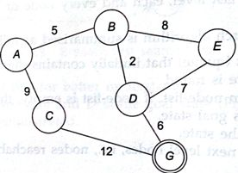

Step 1: Start from A
Step 2: Frontier: A Action: None
Step 3: Frontier: B,C Action: Expanded A


Select the lower i.e B
Step 4: Frontier: D, C, E (priority Queue) Action: Expanded A, B
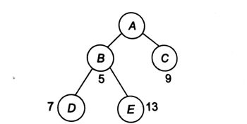

The cost is added from the root till the node in consideration. Select the lower i.e D
Step 5: Frontier: C, E, E, G Action: Expanded A, B, D
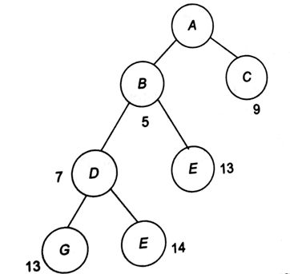

In step 5 we have considered E(again), as its parent is different. The path is A-B-D-G.
Properties of Uniform cost search:
- Complete- Yes if cost >=e, where e is minimum cost that every step must have.
Note: We might get stuck in infinite loop if it ever expands a node that has a 0-cost action leading to the same state. Hence for achieving completeness, the cost of every step is greater than some constant ‘e’.
- Optimal - Yes
- Time Complexity–
1 + b + b^2 + b^3 + :.. + b^d + (b^(b+1)- b) = O(b^d+1), i.e., exp.in d ͌ O(b^d)
- Time & Space Complexity = O(b^C/e)
Where, e is the minimum cost of any action and
C is the cost of the optimal solution

Note: O(b^C*/e) is much greater than b^d. But, O(b^C*/e) = b^d if the Cost of every action is 1.

- Depth first search:
Depth first search is another way of traversing graphs, which is closely related to preorder traversal of a tree. Recall that preorder traversal simply visits each node before its children. It is most easy to program as a recursive routine:
preorder(node v)
{
visit(v);
for each child w of v
preorder(w);
}
To turn this into a graph traversal algorithm, we basically replace "child" by "neighbor". But to prevent infinite loops, we only want to visit each vertex once. Just like in BFS we can use marks to keep track of the vertices that have already been visited, and not visit them again. Also, just like in BFS, we can use this search to build a spanning tree with certain useful properties.
dfs(vertex v)
{
visit(v);
for each neighbor w of v
if w is unvisited
{
dfs(w);
add edge vw to tree T
}
}
The overall depth first search algorithm then simply initializes a set of markers so we can tell which vertices are visited, chooses a starting vertex x, initializes tree T to x, and calls dfs(x). Just like in breadth first search, if a vertex has several neighbors it would be equally correct to go through them in any order. I didn't simply say "for each unvisited neighbor of v" because it is very important to delay the test for whether a vertex is visited until the recursive calls for previous neighbors are finished.
The proof that this produces a spanning tree (the depth first search tree) is essentially the same as that for BFS, so I won't repeat it. However while the BFS tree is typically "short and bushy", the DFS tree Is typically "long and stringy".
Just like we did for BFS, we can use DFS to classify the edges of G into types. Either an edge vw is in the DFS tree itself, v is an ancestor of w, or w is an ancestor of v. (These last two cases should be thought of as a single type, since they only differ by what order we look at the vertices in.) What this means is that if v and w are in different subtrees of v, we can't have an edge from v to w. This is because if such an edge existed and (say) v were visited first, then the only way we would avoid adding vw to the DFS tree would be if w were visited during one of the recursive calls from v, but then v would be an ancestor of w.

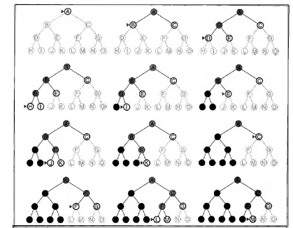
Fig: DFS on binary tree with Goal as ‘M’. Nodes that have been expanded and have no descendents in the fringe can be removed from memory and are shown in black.

Properties of depth-first search:
- Complete - No: fails in infinite-depth spaces, or spaces with loops. Complete only in finite spaces.
- Optimal - No
- Time - O(b^m): terrible if ‘m’ is much larger than ‘d’ but if solutions are dense, may be much faster than breadth-first
Space - O(bm)

- Depth Limited Search:
- DLS is depth-first search with depth limit ‘d’.
- The basic idea is not allowing expansion after the certain depth. The Depth limit solves infinite path problem.

Algorithm:
- Set the depth limit to the maxdepth to search
- Initial Node = Current Node
If initial node = goal then return SUCCESS
- If depth(initial node)>depthlimit then return
Else
Expand(initial node)
Save(successors) using start
Go to Step 2

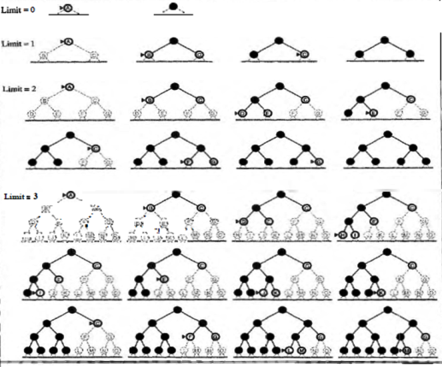
Fig: Four Iterations of IDS on a binary tree.

Properties of Depth-Limited Search:
- Complete - No
- Optimal – No
If we choose l<d and the shallowest goal is beyond depth limit. Then it would neither be complete not optimal.
- time complexity is O(b^l)
- Space complexity is O(bl)

- Iterative Deepening Search (IDS) or DFID (Depth-First Iterative Deepening)
- While still an unintelligent algorithm, the iterative deepening search combines the positive elements of breadth-first and depth-first searching to create an algorithm which is often an improvement over each method individually.
- An iterative deepening search operates like a depth-first search, except slightly more constrained--there is a maximum depth which defines how many levels deep the algorithm can look for solutions. A node at the maximum level of depth is treated as terminal, even if it would ordinarily have successor nodes. If a search "fails," then the maximum level is increased by one and the process repeats. The value for the maximum depth is initially set at 0 (i.e., only the initial node). This continues until a solution is found
- In many cases depth limit restrict the depth limit from finding the solution as the solution may exists beyond the depth limit. IDS help in addressing such problem.
- It extents the depth limit as limit=limit+1 and so on this we find solution.
- An interesting observation is that the nodes in this search are first checked in the same order they would be checked in a breadth-first-search; however, since nodes are deleted as the search progresses, much less memory is used at any given time.

Drawback:
- The drawback to the iterative deepening search is clear from the walkthrough--it can be painfully redundant, rechecking every node it has already checked with each new iteration.
- The algorithm can be enhanced to remember what nodes it has already seen, but this sacrifices most of the memory efficiency that made the algorithm worthwhile in the first place, and nodes at the maximum level for one iteration will still need to be re-accessed and expanded in the following iteration.
- Still, when memory is at a premium, iterative deepening is preferable to a plain depth-first search when there is danger of looping or the most efficient solution is desired.

Algorithm:
- Set depth limit ← 0
- Do
Solution = DLS (Depth limit, initial node)
If(solution = goal state)
Then return
Else
Depth limit = depth limit +1
Continue

Properties of IDS:
- Complete - Yes
- Optimal – Yes
- Time complexity is O(b^d) , where d is the depth limit reached.
- Space complexity is O(bd) , where d is the depth limit reached.

- Bidirectional search
Bidirectional search is a graph search algorithm that finds a shortest path from an initial vertex to a goal vertex in a directed graph. It runs two simultaneous searches: one forward from the initial state and one backward from the goal, stopping when the two meet in the middle. The reason for this approach is that in many cases it is faster: for instance, in a simplified model of search problem complexity in which both searches expand a tree with branching factor b, and the distance from start to goal is d.
As in A* search, bi-directional search can be guided by a heuristic estimate of the remaining distance to the goal (in the forward tree) or from the start (in the backward tree).

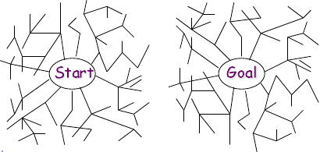
Fig: A systematic view of bi-directional search that succeeds when a branch from start node meets branch from the goal node.
Properties of Bidirectional Search:
- Complete - Yes
- Optimal – Yes
- Time complexity is O(b^d/2).
- Space complexity is O(b^d/2).

- Mathematical Model
S= {s, e, I, O, Fs, DD,NDD,Sc, Fc}
where ,
s=start state
initialization of graph
e=end state
i.e. Print DFS order and BFS order and no. of cycles and hops in graph
I={V,E}
where
V=vertices
E=edges
O={O1,O2}
where
O1=finding hops using BFS
O2=finding cycles using DFS
Fs={f1,f2}
f1 be function for finding hops.
f1(I)->O1
f2 be function for finding cycles.
f2(I)->O2

STATE DIAGRAM:
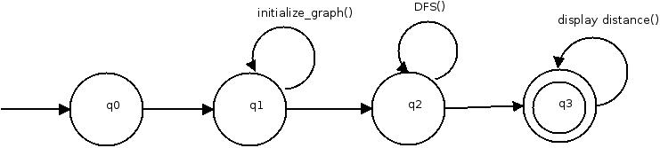
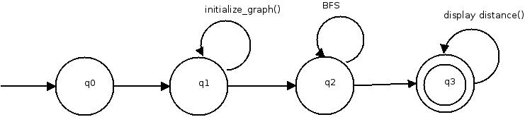

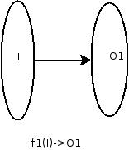
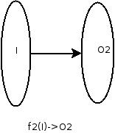
FUNCTION DEPENDANCY DIAGRAM:

DD = Deterministic Data
i.e. Cycles will only be counted for simple graph , not complex graph
NDD = Non-deterministic Data
i.e. 1) No. of vertices/nodes in graph
2) Edges between nodes
3) Weight of edges
4) BFS/DFS Traversal
Sc be success case.
Sc=
1) DFS traversal path successfully printed
2) BFS traversal path successfully printed
3) Total no of hops
4) No. of cycles
Fc be failure case.
Fc=Disconnected graph

TEST CASES:
Test Case No | Test Case | Input | Expected Output | Actual output
1 | Detect number of cycles | 0 1 1 0  1 0 0 1  1 0 0 1  0 1 1 0 | 1 | 1
2 | Detect Display hop count | 0 1 1 0  1 0 0 1  1 0 0 1  0 1 1 0 | A to A -> 0  A to B -> 1  A to C -> 1  A to D -> 2 | A to A -> 0  A to B -> 1  A to C -> 1  A to D -> 2

- Conclusion:
Thus we have studied graph traversing method and implemented uninformed search methods.

